Product Service Codes (PSCs) Management

Standard Operating Procedures

June 2019

I. Introduction 2
A. Purpose 2
B. Background 2
C. Process 2
II. Standard Operating Procedure (SOP) 2
IV. Roles and Responsibilities 3
V. Governance 4
VI. Work Flow 4
Cycle for Submitting Business Cases 5
Step 2 - Assign Change Requests 5
Step 3 - Review and Analyze 6
Step 4 - Recommendations 6
Posting to OMB MAX 6
Step 5 - Review Business Cases 6
Step 6 - SMEs Briefing 7
Step 7 - PCE Approvals 7
Appeals 7
Step 8 - Implement Changes 7
Communications 8
Summary of Changes to PSC Codes 8
Appendix A - Web Form – Request for PSC Changes 9
Appendix B - PSC Change Business Case 10
Appendix C - Product Services Code Spreadsheet 11
Appendix D - Sample – Inform Users 12

I. Introduction

A. Purpose
The purpose of this Standard Operating Procedure (SOP) is to document the process for the administration and management of the Product Service Codes (PSCs) to ensure the accurate reporting of Federal spending data related to procurements. To maintain the flexibility for future changes, the PSCs may be added, revised, or deleted to increase the accuracy of reporting. By ensuring periodic updates, the PSCs are expected to improve system usability by minimizing the use of miscellaneous PSCs when a more specific one is available, leading to more accurate reporting.

B. Background
The Federal Government uses more than 3,000 PSCs to describe the different types of products and services purchased by the federal government. These codes are reported to a variety of federal systems, including agencies’ contract writing systems, the Federal Procurement Data System – Next Generation (FPDS-NG) and other Integrated Award Environment (IAE) systems, USAspending, and other industry systems. The PSCs are instrumental for reporting; are critical for government leadership to understand how federal dollars are spent; and help the Federal government determine how much money is being spent on specific products or services.

The PSCs are also used to study existing trends in Federal spending; report on international agreements; analyze regulatory burden; and reflect changes in technology and terminology. The PSCs identify commodities with environmental or other attributes; are used to generate ad hoc, statutory, and international reporting; and link procurement systems to contracting and financial data. Civil and defense logistics operations and processes use PSCs extensively to track quality and pricing of parts.

C. Process
The management of PSCs has been aligned to leverage experts in each field while retaining a governmentwide view that would balance better data management with workforce and burden considerations. To meet those needs, the Subject Matter Experts (SMEs) for the various codes are drawn from Federal-wide category managers, the Research and Development Community, and the Department of Defense for defense-centric spending codes (see Appendix C - PSC spreadsheet). GSA continues to rely on the Federal interagency governance of procurement data, the Procurement Committee for E-government (PCE) for managing procurement data.

II. Standard Operating Procedure (SOP)
This SOP, coordinated with the Procurement Committee for E-Government, the Category Management Program Management Office (PMO), the Federal R&D Community of Practice, and DoD, implements a standardized process for managing the PSCs by utilizing the expertise of these SMEs. This includes the updating of PSCs for the product and/or services in all areas by aligning management of the codes with the experts in each.

The PSC SOP applies to all SMEs responsible for managing the codes as well as the organizations responsible for governing and maintaining the codes to include:

- SMEs for each area
- DoD
- the Federal R&D CoP
- GSA IAE
- PCE

IV. Roles and Responsibilities
The SMEs are either Category Managers from the GSA, the DoD, the Department of Homeland Security (DHS), the Office of Personnel Management (OPM), the Department of Veterans Affairs (VA), or the Federal R&D Community of Practice. These experts are aware of the latest advances in their respective areas of spend; the coding needed to further their knowledge of government spend; and the insight needed to manage spend to support the government in making better buying decisions.

Outlined below are the roles and responsibilities of all parties involved in the PSC Management Process.

- SMEs
  - lead the review and analysis of the proposed changes to PSCs within a specific area;
  - document analysis, recommend changes, and rationale for recommendations
  - coordinate with other SMEs as appropriate;
  - consult with the PCE on data management proposals in the PSCs;
  - incorporate feedback from other SMEs and the PCE, and develop final changes (numbering, definition, and naming) to PSCs;
  - complete reconciliation of PCE comments and submit revised business cases incorporating change before requesting to be added to the PCE agenda;
  - lead final concurrence process with PCE and other SMEs on the changes; and
  - notify stakeholders of PSC changes and work with the FAI and DAU on any tools and/or training necessary for the new changes to take place across the workforce.

- DoD
  - is the SME for the PSCs in Defense-Centric Spend Categories 11-16, 18, and 19, and has designated DLA as its SME who manages the addition, deletion, and revision of PSCs correlated to supply FSCs in Categories 11, 12, 13, 14, and 19;
  - handles change requests for these PSCs in accordance with the DoD’s established review, governance, and approval processes; and
  - follows the established DoD policies, governance, and processes to analyze and approve proposed changes to codes.

- Federal R&D Community of Practice (CoP)
  - SME for the Federal R&D CoP as noted in OMB Circular A-11;
  - is the SME for PSC in Spend Category 17; and
  - handles change requests for these PSCs in accordance with its established review, governance, and approval processes.

- Integrated Award Environment (IAE)
  - is the central coordination point for all users (Federal and public) to submit requested changes to the PSCs;
  - manages the data capture and display changes necessary in the IAE’s suite of applications to ensure the timely updating of PSCs;
  - implements the necessary system changes twice per year; and
  - identifies more data-centric information technology capabilities for updating the PSCs.
- Procurement Committee for e-Government (PCE)
  - provides the final decision on all PSC changes--additions, deletions, and revisions, by considering the need for accurate data to meet spending analysis decisions and offering alternative solutions for meeting the objectives of the desired changes;
  - advises and recommends actions related to the collection, dissemination, and display of procurement data;
  - ensures the proposed data reporting requirements are appropriate and meet functional requirements and operational feasibility; and
  - reviews interim results as needed.

V. Governance
The governance process for the PSCs supports changes in the federal acquisition and procurement data landscape as well as changes in how agencies strategically approach spending decisions. The PCE provides guidance, recommendations, and governance over the integrated environment designed to provide efficient and effective access to timely data required by federal procurement professionals. It is the overarching governance and the final decision-maker for adding, deleting, and revising the PSCs outside of the defense-centric codes. If there are disagreements between the SMEs and the PCE regarding changes to the PSCs, the Office of Management and Budget (OMB) will resolve the dispute(s).

VI. Work Flow
All SMEs are expected to adhere to the work flow outlined in Diagram 1 - PSC Change Request Work Flow, illustrated below, for change requests and business cases:

Diagram 1 - PSC Change Request Work Flow

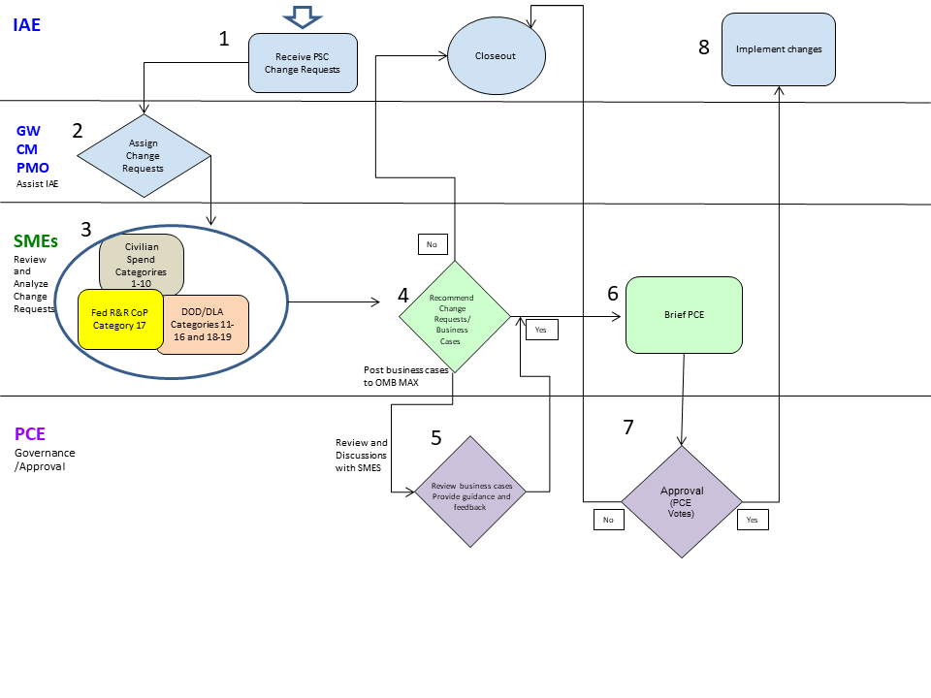

Cycle for Submitting Business Cases
The SMEs may present business cases at one of the six PCE meetings scheduled during the calendar year provided the final versions of the materials are posted to OMB MAX PSC Page three (3) weeks in advance of the next scheduled PCE meeting. IAE will share the date and time of next scheduled PCE meeting with the SMEs when it becomes available. The PCE meeting agenda will outline the order and duration of the SMEs’ presentation of the business cases.

Step 1 - PSC Change Requests
Proposed PSC change requests from the public, industry, interested stakeholders, and federal agencies are received from the Product Service Code Change Request web form available on the IAE Federal Service Desk (FSD) website at www.fsd.gov. Change requests submitted directly to the SMEs are expected to follow the work flow as outlined above in Diagram 1.

Users may submit change requests recommending additions, revisions, or deletion of PSC codes in order to better track spend, formalize usage for increased consistency in PSC selection, and align commodity spend for better management and tracking. Creating new PSC codes help eliminate redundancy, allow clearer identification of commodities and industries under represented by existing codes, and increase accuracy reported spend data.
Users change request may recommend the repurposing of existing PSCs whereby the PSC’s description, title, or other attributes are changed to facilitate more accurate reporting for the specific commodities which the revised PSC would cover. There are also many PSC codes that are used legitimately but very infrequently. Users can recommend removal of these PSC codes due to their obsolescence or disuse to further lessen the opportunities for spend data degradation. The existence of these underused PSC codes with outdated or ambiguous attributes and function can over a period of time lead to unintentional use and erroneous reporting.

Step 2 - Assign Change Requests
The Governmentwide Category Management Program Management Office (GW CM PMO) will assist IAE with assigning the proposed change requests for PSC in the Civilian Spend Categories 1-10 to the appropriate SMEs. DoD’s SMEs will be forwarded change requests for PSCs in the Defense-Centric Spend Categories 11-16, 18, and 19. The Federal R&D CoP will receive all PSC change requests identified for Category 17.

Step 3 - Review and Analyze
The SMEs for Civilian Spend Categories shall review and analyze the assigned PSC change requests in accordance with their respective established processes. DoD’s SMEs will review and analyze assigned change requests in accordance with DoD’s established processes; DLA manages and follows DoD policies and processes to analyze and approve proposed changes to PSCs related to supply. The Federal R&D CoP will review and analyze change requests identified for R&D or Category 17 in accordance with its established processes.

Step 4 - Recommendations
The SMEs shall complete Appendix B - PSC Change Business Case if they are recommending the proposed PSC change requests to the PCE. The business case proposal is to be filled out, even if the SME disagrees with the proposed solution. The business cases and supporting documentation that are to reviewed by the PCE will be:

- posted to OMB MAX at https://community.max.gov/display/Management/Product+Service+Code+%28PSC%29+Management, as this allows the PCE and the SMEs to have visibility to the feedback process, and
- used as the basis for the SMEs formal presentation to the PCE.

The SMEs in all areas must brief the PCE to obtain interagency feedback and approval on the recommended proposed solutions for data management. For PSC change requests not recommended to the PCE, the SMEs shall provide the submitter the rationale for the rejection as documented in the business case.

Posting to OMB MAX
All SMEs are required to post their initial and revised business cases in the respective individual folders on the OMB MAX PSC Management page, https://community.max.gov/display/Management/Product+Service+Code+%28PSC%29+Management as this allows the PCE and the SMEs to have visibility to the feedback process.
The main page of the PSC Management page lists summary folders, SOP folders, and individual PSC folders. The summary folders provide limited information on the proposed PSC. However, each individual PSC folder created on the main page has four sub-folders: "Initial Business Case”, “Revised Business Case”, “Approved Business Case", and "Withdrawn/Reject Business Case".
Before the business cases are posted to the OMB MAX PSC Management page, the SMEs will notify IAE at PSC-Codes@gsa.gov so IAE can create and name the individual PSC folders and subfolders for managing the posting of documentation. IAE updates the statuses posted in the summary folders.
Business cases posted to shall follow the applicable file format for posting. The SME shall enter either the proposed PSC name or number for the in the file name. For document version control, initial business cases shall use the file format “Initial Business Case PSC (name or number) monthdayyear” and the revised business cases shall use the file format “Revised Business Case PSC (name or number) monthdayyear”.

Step 5 - Review Business Cases
Each month, the PCE members shall use the link https://community.max.gov/display/Management/Product+Service+Code+%28PSC%29+Management to check the PSC folders for new postings (initial business cases and revised business cases) that need to be reviewed. The PCE may review and provide comments and questions on the initial and revised business cases posted to OMB MAX,

The SMEs will work with commenters to address questions and concerns regarding either the initial or revised business cases, sharing adjudication in OMB MAX. Once resolved, the SMEs shall ensure the final versions of the materials (revised business cases and any supporting documentation) are posted to the OMB MAX PSC Page at least three (3) weeks prior to the date of the scheduled PCE briefing. Only after the SME and the PCE have resolved all outstanding issues regarding the business cases shall the SMEs coordinate with IAE to schedule the presentation to the PCE.

Step 6 - SMEs Briefing
At the formal briefing, the SMEs will present the business cases submitted in accordance with “Step 5” above. During the briefing, the PCE may engage in further discussions to address additional questions or concerns that may arise during the briefing.

Business cases that are revised as a result of this collaboration are expected to be posted to OMB MAX https://community.max.gov/display/Management/Product+Service+Code+%28PSC%29+Management within two (2) calendar days after the meeting so the PCE can vote on the final version. The PCE may elect to vote on the business cases at its next meeting if the changes to the business cases cannot be made within two (2) calendar days.

Step 7 - PCE Approvals
At conclusion of the SMEs briefings, the PCE will vote on each business case. The SMEs will be excluded from the PCE’s voting process, which may be conducted either electronically or verbally. The PCE is not required sign any documentation. Once the PCE’s final determination is made, the PCE meeting notes from the date the presentations occurred will serve as the official documentation of the PCE’s approval or disapproval of business cases.

Appeals
Any disagreements in data management among the stakeholders will be resolved by OMB.

Step 8 - Implement Changes
IAE intends to update the PSC information in its systems semi-annually. For PSC changes, here is the schedule:
- July 31st deadline for October implementation
- January 31st deadline for April implementation
Business cases approved 90 days in advance of the system release will become eligible for inclusion in the next semi-annual PSC update in the IAE systems. When IAE implements a PSC-module/manager in Beta.SAM.gov, IAE will revisit the process for incorporating the PSC changes.

To reduce the burden for PSC updates in agency’s award systems, IAE provides a PSC application program interface (API) with all of the PSC updates. The PSC API can be accessed at https://beta.sam.gov/data-services. If agencies are not using the PSC API, agencies should plan resources to update their systems to reflect the PSC changes to keep PSC information in their systems current.

The IAE’s Change Control Board (CCB) does not vote to approve the PSC business cases; however, IAE will notify the CCB of PSC changes approved by the PCE and the expected implementation date.

IAE does not enhance its systems in the 4th quarter of the fiscal year so all system changes must be completed and tested during the 3rd quarter in order to support use by the workforce at the start of a new fiscal year.

Communications
IAE will post a notice, such as the draft in Appendix D - Sample – Inform Users, through GSA Interact, IAE’s CCB’s weekly updates, Federal Acquisition Institute (FAI) newsletter, or other mediums to inform users and stakeholders that the new PSC are ready for use. IAE will notify DLA and any other agencies with any changes to PSCs related to supply codes within a minimum of 60 days of implementation so they can update their databases.

If dedicated training is needed to support the implementation of the PSC, the SMEs shall coordinate with FAI to develop the applicable training material needed for the acquisition workforce and industry.

Summary of Changes to PSC Codes
IAE, as the administrator of the PSCs, is responsible for archiving the information related to PSC changes. IAE will retain all legacy data in accordance with record retention requirements. IAE will keep a history of the code changes for analytical, research, and reporting purposes.

The IAE PSC API can be accessed at https://beta.sam.gov/data-services. Go to the link, select the “Documentation” file and then the “PSC file” to access the “PSC Public API” file.

For users unable to utilize the API application, IAE will update the “hardcopy” version of the PSC Manual and other supporting documentation posted on FPDS and any other sites where IAE posts this information for user research will coincide with the “go live” dates of the system changes.

Appendix A - Web Form – Request for PSC Changes
https://docs.google.com/forms/d/e/1FAIpQLSfEkzQRChTAiE87Kh1aqIedidDg_yv_EVHcGxsfrHJYvfJlJQ/viewform

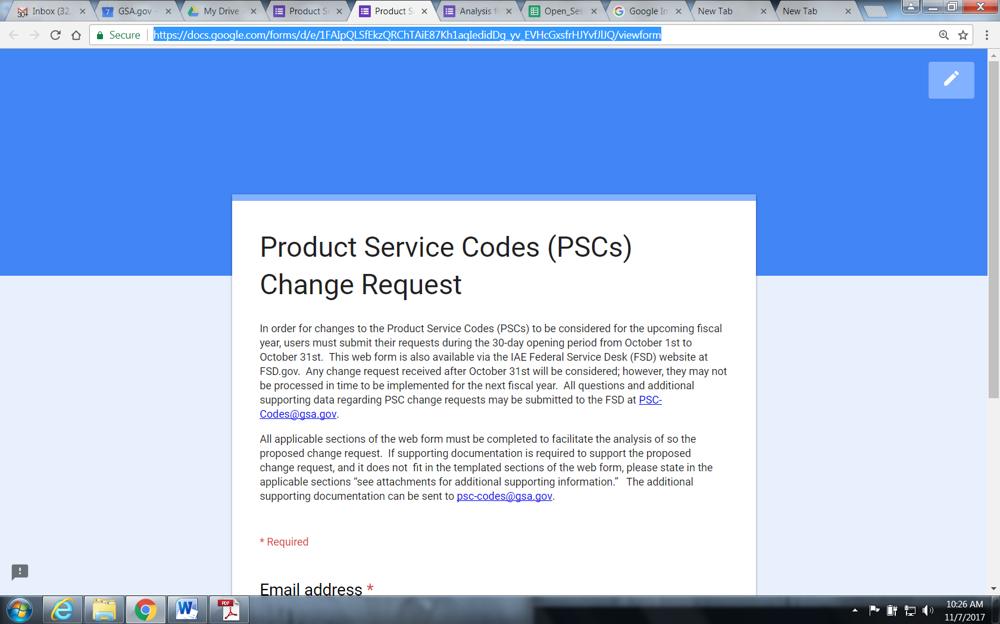

Appendix B - PSC Change Business Case

Appendix C - Product Services Code Spreadsheet
The PSC spreadsheet shows the alignment of the PSC among the 19 spend categories. This includes Common governmentwide spend categories, the R&D Categories, and the Defense-centric spend categories, and the points of contacts for the spend categories.

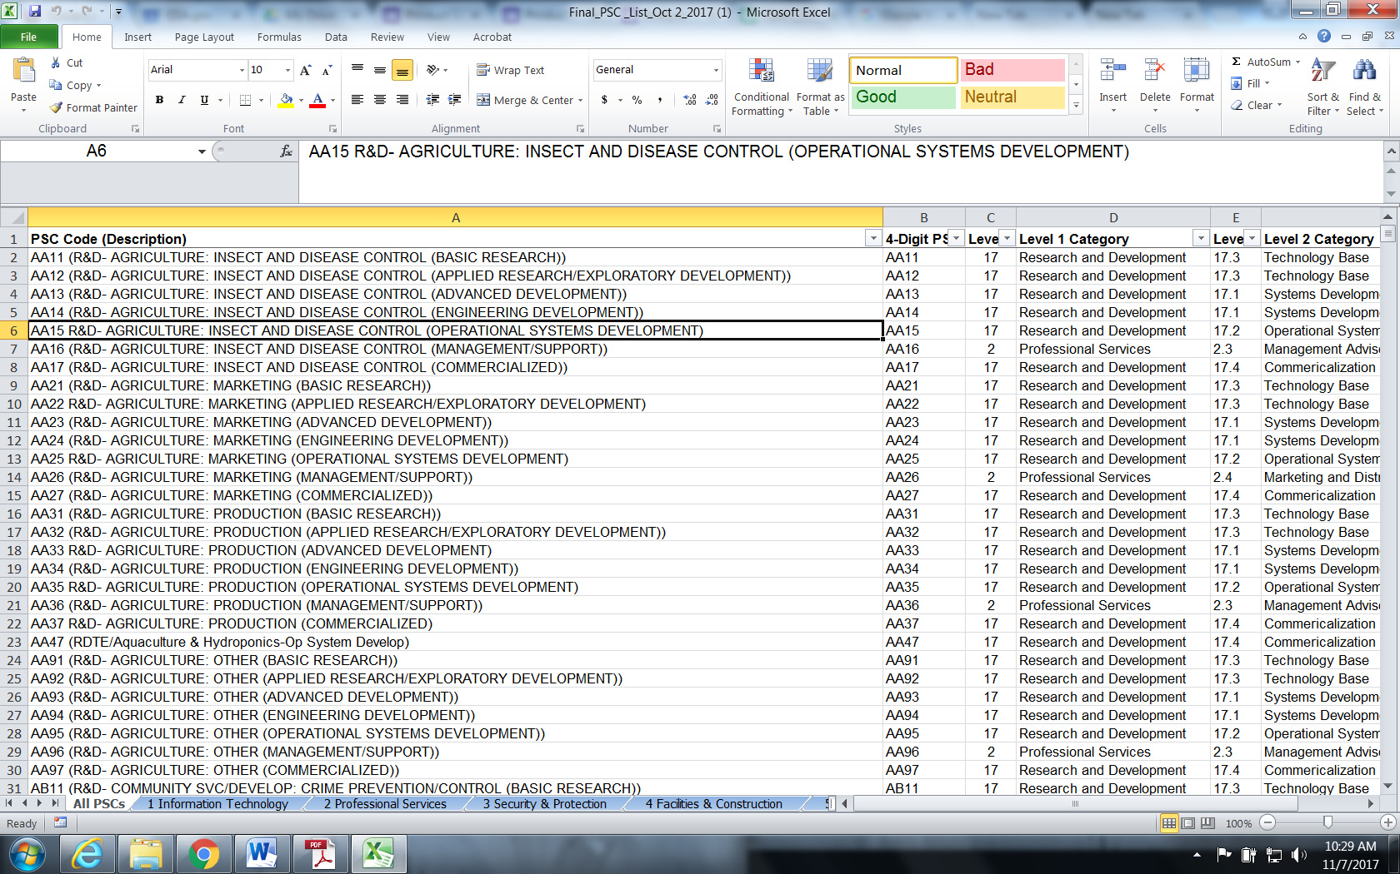

Appendix D - Sample – Inform Users

The following is a template of a public notice to announce to users and stakeholders that the new codes are ready for use.

New Changes to the Product Service Codes

The General Services Administration’s Integrated Award Environment (IAE) has implemented changes to the Product Service Codes (PSCs). The IAE will implement the approved PSCs in its suite of systems and applications. These codes will be effective on [DATE] for use. See the attachments for the list of new PSCs that will be ready for use.

The PSCs describe the products, services, and research and development items purchased by the federal government, and are used in collecting and analyzing federal procurements.

For updates about the PSCs, visit our blog and sign up at Integrated Award Environment (IAE) Industry Community or email us at PSC-Codes@gsa.gov.

Attachments:

- PSC Additions
- PSC Revisions
- PSC Deletions
- Other documents

